**ՀՀ ԿՐԹՈՒԹՅԱՆ ԵՎ ԳԻՏՈՒԹՅԱՆ ՆԱԽԱՐԱՐՈՒԹՅՈՒՆ**

**ՀԱՅԱՍՏԱՆԻ ԱԶԳԱՅԻՆ ՊՈԼԻՏԵԽՆԻԿԱԿԱՆ ՀԱՄԱԼՍԱՐԱՆ**

**ՆԱԽԱԱՎԱՐՏԱԿԱՆ ՊՐԱԿՏԻԿԱՅԻ**

**ՀԱՇՎԵԲԱՑԱՏՐԱԳԻՐ**

Ինստիտուտ՝ ՏՀՏԷ

Ամբիոն՝ ՏԱԾԱ

Խումբ՝ TT019a

Ուսանող՝ Andy Younes

Ղեկավար՝ Arman Grigoryan

**ԵՐԵՎԱՆ 2024**

DEVELOPMENT OF A MACHINE LEARNING ALGORITHM FOR RESTORING DAMAGED IMAGES

**TABLE OF CONTENT**

INTRODUCTION 3

CHAPTER I: LITERATURE REVIEW AND RESEARCH SCOPE 4

1.1 Significance of Image Restoration 4

1.2 Image Restoration Techniques 6

1.3 Machine Learning 8

1.4 Variants of Machine Learning algorithms 15

1.5 Problem Statement 19

CHAPTER II: INNOVATIVE DEVELOPMENTS AND CORE CONTRIBUTIONS 20

2.1 Training the Hybrid Model for Image Restoration 20

2.2 Traditional Algorithms Integration 24

2.3 Training Regimen Overview 28

2.4 Hybrid Approach 32

CHAPTER III: AUTOMATION AND TECHNOLOGY 35

3.1 Programming Environment 35

3.2 User Interface 38

3.3 Hybrid Machine Learning Algorithm Development and Results 46

CONCLUSION 50

REFERENCES 52

# INTRODUCTION

In recent years, the field of image processing has witnessed significant advancements, with machine learning playing a pivotal role in transforming the way we perceive and enhance digital imagery. One of the compelling challenges within this domain is the restoration of damaged images, a task with wide-ranging applications in various sectors, including medical imaging, forensics, and historical document preservation. This thesis embarks on the journey of developing a novel machine learning algorithm for the restoration of damaged images, employing a hybrid approach that amalgamates the strengths of multiple techniques.

The restoration of damaged images involves the intricate task of reconstructing visual information that has been corrupted or degraded due to various factors such as noise, blur, compression artifacts, and other forms of deterioration. Traditional image processing techniques often struggle to handle the complexity and variability inherent in damaged images, leading to limitations in their restorative capabilities. Machine learning, with its ability to discern patterns and relationships within data, presents a promising avenue for addressing these challenges.

The proposed algorithm adopts a hybrid machine learning approach, leveraging the synergy between different methodologies to enhance the restoration performance. This hybridization involves integrating deep learning techniques, such as convolutional neural networks (CNNs), with classical image processing methods, harnessing the respective strengths of both paradigms. By combining the feature extraction power of deep learning with the contextual understanding and domain-specific knowledge of classical methods, the algorithm aims to achieve superior restoration outcomes.

Furthermore, the development of this algorithm will explore the significance of a robust training dataset, acknowledging the diversity of damaged images in real-world scenarios. The training process will involve exposing the algorithm to a wide array of damaged image samples, enabling it to learn and generalize effectively. The performance of the algorithm will be evaluated through quantitative metrics and qualitative visual assessments, ensuring its efficacy in restoring images across various damage types and severity levels.

In conclusion, this thesis endeavors to contribute to the burgeoning field of image restoration by presenting a novel machine learning algorithm that integrates the best of both deep learning and classical image processing techniques. The hybrid approach is poised to provide a more comprehensive and adaptive solution for the restoration of damaged images, pushing the boundaries of what is achievable in the realm of digital image enhancement.

# CHAPTER I: LITERATURE REVIEW AND RESEARCH SCOPE

## Significance of Image Restoration

In the realm of image processing, the restoration of damaged images stands as a formidable challenge with far-reaching implications across diverse fields. As technology advances and imaging devices become omnipresent, the need for effective solutions to enhance and recover visual information from degraded images becomes increasingly pressing. Traditional image processing methods, while successful in many applications, exhibit limitations when faced with the complexity and variability inherent in damaged images.

This chapter sets the stage for a comprehensive exploration of image restoration through the lens of advanced machine learning techniques. The focus of this research is to address the inherent shortcomings of conventional approaches by developing a novel hybrid machine learning algorithm. This algorithm aims to seamlessly integrate the strengths of deep learning, specifically convolutional neural networks (CNNs), with classical image processing methodologies. The fusion of these paradigms is envisioned to yield a powerful and adaptive solution capable of restoring images suffering from various forms of degradation, such as noise, blur, and compression artifacts.

The objective is to reduce noise and recover resolution loss. Image processing techniques are performed either in image domain or the frequency domain. The most straightforward and conventional technique for image restoration is deconvolution, which is performed in the frequency domain and after computing the Fourier transform of both the image and the PSF and undo the resolution loss caused by the blurring factors. Nowadays, photo restoration is done using digital tools and software to fix any type of damage images may have and improve general quality and definition of the details.

* 1. Image Degredation Process

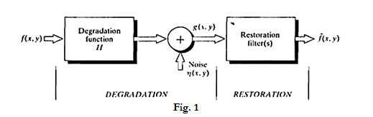Image restoration is the process of recovering an image that has been degreded by some knowledge odegredation function H and the additive noise term $η\left(x,y\right).$ This in restoration, degredation is modelled and its inverse process in applied to recover the original image.

Fig.1: Image Degredation Process

Objective is to obtain an estimate of the original image $f(x,y)$. We find appropriate restoration filters so that output image $\hat{f}\left(x,y\right)$ is as close as the original image $f\left(x,y\right)$ since it is practically not possible to completely restore the original image.

Terminology:

* $g\left(x,y\right) =$ degraded image (1)
* $f\left(x,y\right) =$ input or original image (2)
* $\hat{f}\left(x,y\right) =$ recovered or restored image (3)
* $η\left(x,y\right) =$ additive noise term (4)

In spatial domain:

$g(x,y)=h(x,y)⊛f(x,y)+η(x,y)$

Where $⊛$ represents convolution.

In frequency domain:

After taking Fourier transform of the above equation:

$G\left(u,v\right)=H\left(u,v\right)F\left(u,v\right)+N\left(u,v\right)$ (6)

If the restoration filter applied is $R(u,v)$, then

$\hat{F}\left(u,v\right)=R\left(u,v\right)\left[G\left(u,v\right)\right]$ (7)

$\hat{F}\left(u,v\right)=R\left(u,v\right)H\left(u,v\right)F\left(u,v\right)+R\left(u,v\right)N\left(u,v\right)$ (8)

$\hat{F}\left(u,v\right)≈F\left(u,v\right)$ (for restoration) (9)

As restoration filter $R\left(u,v\right)$ is the reverse of degration function $H\left(u,v\right)$ and neglecting noise term. Here $H\left(u,v\right)$ is linear and position invariant.

1. Limitations of Traditional Approach

Traditional approaches for image restoration are rooted in mathematical and physical theories, often based on texture consistency and content similarity. These methods typically involve deterministic and stochastic techniques to address varying degrees of image degradation.

Traditional upscaling methods, while useful in certain scenarios come with several limitations that can impact the quality of the upscaled images.

We often suffer from Loss of detail, struggling to retain fine details in the upscaled images. As algorithm extrapolates from existing pixels, intricate details may get lost or become blurry. Aside from that, these methods lack a deep understanding of the image content. They often rely on simple interpolation techniques, leading to suboptimal results, especially in complex scenes.

In addition let us not forget artifacts and noise, upscaling can introduce artifacts and noise, creating unnatural patterns or distortions in the image. This is particularly noticeable in areas with high contrast or intricate textures. And the inability to handle non-linear transformations, when the relationship between pixels is complex or varies across the image, the results may be unsatisfactory.

Furthermore, maintaining accurate and consistent colors can be challenging. That means that upscaling methods may produce color shifts or inaccuracies, affecting the overall visual appeal of the image. While traditional upscaling can increase image size, it may not necessarily improve sharpness. Edges may appear jagged, and the overall quality may not meet expectations. Although, some methods rely heavily on pre-existing datasets for training. If the training data does not adequately represent the variety of images encountered, the upscaling performance may suffer.

Finally, certain advanced upscaling methods, especially those based on deep learning, can be computationally intensive. This may limit their practicality for real-time applications or on devices with limited processing power.  Traditional methods may struggle to upscale images containing artistic elements or unconventional compositions. The lack of understanding of artistic intent can lead to unintended alterations.

As a result of these limitations, emerging technologies, such as deep learning-based super-resolution methods, are actively being explored to overcome these challenges and achieve more realistic and visually appealing upscaled images. These advanced techniques leverage neural networks to better understand image content and produce superior results compared to traditional upscaling methods.

## Image Restoration Techniques

Digital images are prone to various types of degradation such as noise, blur, and compression artifacts due to factors like poor lighting, low-quality camera sensors, and image transmission over the internet. Digital image restoration is the process of improving the quality of a degraded digital image by applying various techniques to remove or reduce the degradation. However, restoring images to their original quality is a complex process that comes with several challenges. In this blog post, we will discuss digital image restoration techniques and the challenges involved. There are several techniques used for image restoration, and each technique has its own advantages and disadvantages. Here are a few of the most commonly used techniques:

1. Filtering

Filtering is a widely used technique for restoring degraded images. It involves using a filter to remove unwanted noise and blur [[1]](https://medium.com/@shashikadilhani97/digital-image-processing-filters-832ec6d18a73). This technique is commonly used in image processing to improve the quality of images that have been degraded due to factors like poor lighting, camera shake, or low-quality equipment.

Common filters include the median filter, which replaces each pixel with the median value of its neighboring pixels to remove unwanted noise. The Wiener filter minimizes the mean square error between the original and filtered images, making it ideal for images with additive noise. Gaussian filters [[2]](https://www.southampton.ac.uk/~msn/book/new_demo/gaussian/#:~:text=The%20Gaussian%20Smoothing%20Operator%20performs,defines%20the%20amount%20of%20blurring.), on the other hand, smooth the image and reduce noise by convolving the image with a Gaussian kernel.

By applying the appropriate filter, users can effectively remove unwanted noise and blur, resulting in images that are clearer, sharper, and more visually appealing

1. Deconvolution

Deconvolution is a powerful technique used in image processing to remove blur from an image. It is often used in situations where an image has been degraded by a known point spread function. Essentially, deconvolution works by reversing the convolution process that caused the blur in the first place. This can be thought of as a kind of “unblurring” of the image. By removing the blur, important details and features of the image that were previously obscured can be revealed. Deconvolution [[3]](https://www.sciencedirect.com/topics/neuroscience/deconvolution#:~:text=Deconvolution%20is%20a%20computationally%20intensive,with%20higher%20contrast%20and%20resolution.) has a wide range of applications in fields such as astronomy, microscopy, and medical imaging, and is an important tool for researchers and professionals working in these areas.

Deconvolution microscopy typically is applied to 3D image stacks. With an epifluorescence widefield microscope, it is accomplished with very high quality (high NA, highly corrected) objectives, a spatially and temporally stabilized light source, a highly accurate and reproducible *z*-axis stepper motor, and a highly sensitive cooled-CCD or CMOS camera with low read out noise, 12 bit or higher A/D converters, and a uniform spectral response. The z step size for optical sections is typically around 500 nm, ranging from about 250 to 750 nm. This step size must be accurate and must not be distorted by mechanical or thermal influences that might cause drift. Light sources may include laser, LED or arc sources that possess high intensities at the required wavelengths and are spatially stabilized by passing the light through an optical fiber [[9]](https://www.sciencedirect.com/topics/social-sciences/optical-fibres) or other type of optical scrambler. The z-stack images acquired should be of equal exposure and free of photobleaching and clipping (i.e., saturation).

The most sophisticated form of deconvolution requires a 3D stack of the point spread function (PSF) of a subresolution bead (typically 0.1 μm diameter) mounted in the same medium, either within the same preparation as the specimen or in a separate preparation. A 3D stack of images is taken through focus using the same conditions as those used for the specimen and at the same wavelength or wavelengths if the multiple probes are to be imaged.

Deconvolution algorithms utilize the following equation to solve for the object structure:

IXYZ= SXYZ⊗PSFXYZ

I(*X*,*Y*,*Z*) represents the 3D image that results from the convolution of the light distribution in the specimen S(*X*,*Y*,*Z*) with that of the PSF of the objective PSF(*X*,*Y*,*Z*). Since the I(*X*,*Y*,*Z*) and PSF(*X*,*Y*,*Z*) are determined, they both are converted (transformed) to Fourier or frequency space where the convolution operation is performed as a simple multiplication. The actual specimen structure S(*X*,*Y*,*Z*) then is solved for and inversely transformed back to real image space.

Deblurring algorithms are the simplest algorithms used for this purpose and are grouped separately from true deconvolution algorithms. The nearest neighbor algorithm uses each image of a 3D stack as a central focal plane plus the two adjacent planes in the stack above and below. It subtracts the defocused information from the adjacent optical sections from the central plane and then repeats this for every image in the stack. The result is a sharpened image. However, only about 10–15% of the brightness remains.

The most widely used deconvolution algorithm is called linear filtering. It subtracts all focal planes from each central plane of the stack and, in addition, uses a specialized filter (Wiener filter [[4]](https://support.ptc.com/help/mathcad/r9.0/en/index.html#page/PTC_Mathcad_Help/wiener_filtering.html) , linear least squares [[5]](https://www.sciencedirect.com/topics/medicine-and-dentistry/least-square-analysis), or inverse filter) to restore original brightness values by reducing noise and high spatial frequency components.

The most sophisticated algorithms are lumped under the category, constrained iterative deconvolution, of which there are several variations. These remove the blur from each image of a 3D stack without reintroducing high frequency noise. Finally, the blind deconvolution method proceeds by calculating the best estimate of both the PSF and the object in blurred image stacks. This negates the need to collect PSF data for each image stack and compensates for inaccurately acquired PSF stacks, but does not compensate for poorly corrected objectives, poorly prepared specimens, or poor microscope setup. Deconvolution can be applied to image stacks derived from widefield, confocal (CLSM [6] and spinning disk), multiphoton and super-resolution imaging.

While classical techniques have proven effective in addressing certain types of image degradation, the advent of deep learning-based approaches has ushered in a new era in digital image restoration. These techniques leverage the power of artificial intelligence to learn complex mappings between degraded and clean images, allowing for more sophisticated and nuanced restoration.

## Machine Learning

Machine learning is a relatively new technique that has gained popularity in recent years. It is a subfield of artificial intelligence that allows machines to learn from data and improve their performance over time. In the case of image restoration, machine learning algorithms are trained on a dataset of degraded images and their corresponding restored images, enabling them to learn patterns and relationships that can be used to restore new images. This technique has been shown to produce impressive results, and has been adopted by many researchers and practitioners in the field of image processing. By leveraging the power of machine learning, image restoration can now be accomplished with greater accuracy and efficiency than ever before.

There are several machine learning algorithms and techniques used for restoring and enhancing images. These algorithms are commonly used in image processing tasks to remove noise, increase resolution, improve quality, and restore damaged or degraded images. Here are some popular machine learning algorithms and methods for image restoration:

**Denoising Autoencoders**

Denoising Autoencoders are neural networks used for dimensionality reduction. Variants like Denoising Autoencoders are used to remove noise from images. We can stack these autoencoders together to form deep networks, increasing their performance.

Additionally, tailor this architecture to handle a variety of data formats, including images, audio, and text. Additionally, customise the noise, such as including salt-and-pepper or Gaussian noise. As the DAE reconstructs the image, it effectively learns the input features, leading to enhanced extraction of latent representations. It is important to highlight that the Denoising Autoencoder reduces the likelihood of learning the identity function compared to a regular autoencoder.

An autoencoder consists of two main components:

* **Encoder:** This component maps the input data into a low-dimensional representation or encoding.
* **Decoder:** This component returns the encoding to the original data space.

During the training phase, present the autoencoder with a set of clean input examples along with their corresponding noisy versions. The objective is to learn a task using an encoder-decoder architecture that efficiently transforms noisy input into clean output.

**Convolutional Neural Networks(CNNs):**

CNNs are commonly used for image restoration tasks, including denoising, super-resolution, and inpainting. CNNs are designed to automatically learn hierarchical representations from input data, making them exceptionally well-suited for tasks like image denoising, deblurring, and restoration. Variants of CNNs such as U-Net and Deep Residual Networks (ResNets) are popular choices. Convolutional neural networks are distinguished from other neural networks by their superior performance with image, speech, or audio signal inputs. They have three main types of layers, which are:

* Convolutional layer
* Pooling layer
* Fully-connected (FC) layer

The convolutional layer is the first layer of a convolutional network. While convolutional layers can be followed by additional convolutional layers or pooling layers, the fully-connected layer is the final layer. With each layer, the CNN increases in its complexity, identifying greater portions of the image. Earlier layers focus on simple features, such as colors and edges. As the image data progresses through the layers of the CNN, it starts to recognize larger elements or shapes of the object until it finally identifies the intended object.

**Architectural Innovations**

The architecture of CNNs is characterized by convolutional layers that enable the network to automatically learn spatial hierarchies of features. Each layer captures different levels of abstraction, allowing the network to understand both low-level details and high-level structures within an image. This hierarchical feature extraction capability is crucial for restoring images with varying degrees of degradation.

**U-Net Architecture**

The U-Net architecture, a specific design within CNNs, has gained popularity in biomedical image restoration. Its unique "U" shape, with skip connections between encoding and decoding paths, facilitates the preservation of fine details during the restoration process. U-Net has demonstrated effectiveness in scenarios where maintaining intricate structures is essential, such as in medical imaging.

**Residual Learning**

Residual networks, commonly known as ResNets, introduced the concept of residual learning. This approach involves learning residual functions, making it easier for the network to capture and retain essential information during the restoration process. ResNets have shown robustness in handling complex degradation patterns and maintaining consistency in the restored images.

**Super-Resolution Convolutional Neural Networks (SRCNN)**

SRCNN is a specific CNN architechture designed for a single-image super-resolution, i.e., increasing the resolution of an image. The SRCNN is a deep convolutional neural network that learns end-to-end mapping of low resolution to high resolution images. As a result, we can use it to improve the image quality of low resolution images.

To evaluate the performance of this network,used image quality metrics:

* peak signal to noise ratio (PSNR)
* mean squared error (MSE)
* structural similarity (SSIM) index

We will also be using OpenCV to pre and post process our images. Also, there is frequent converting of our images back and forth between the RGB, BGR, and YCrCb color spaces. This is necessary because the SRCNN network was trained on the luminance (Y) channel in the YCrCb color space.

**Advantages and Disadvantages**

**Advantages**

* **High-Quality Super-Resolution:**

SRCNN has demonstrated a remarkable ability to generate high-quality super-resolved images. It excels in capturing fine details and textures, making it suitable for applications where enhanced image resolution is crucial.

* **End-to-End Learning:**

SRCNN operates in an end-to-end manner, meaning it directly learns the mapping from low-resolution to high-resolution images without relying on handcrafted features or intermediate steps. This simplifies the model architecture and training process.

* **Adaptability to Different Scaling Factors:**

SRCNN can be trained to adapt to various scaling factors, allowing it to handle different degrees of super-resolution. This flexibility makes it applicable to a wide range of scenarios where diverse levels of image enhancement are required.

* **Efficient Inference:**

Once trained, SRCNN is relatively efficient during the inference phase. The model can process low-resolution images and generate super-resolved outputs with a reasonable computational cost, making it suitable for real-time or near-real-time applications.

**Disadvantages**

* **Limited Generalization to Unseen Data**

SRCNN may face challenges in generalizing well to images with different characteristics than those in the training dataset. It might struggle with handling diverse degradation patterns or scenarios not adequately represented during training.

* **Vulnerability to Artifacts**

In certain cases, SRCNN might produce artifacts in the super-resolved images, such as ringing or checkerboard patterns. These artifacts can be a limitation, especially when the model encounters novel or complex image degradation patterns.

* **Resource Intensive Training**

Training SRCNN requires a substantial amount of computational resources and time, particularly when dealing with large datasets. This can be a limitation for researchers or practitioners with limited access to high-performance computing resources.

* **Fixed Input Size**

SRCNN typically operates on fixed-size patches during training and inference. This constraint may limit its ability to handle images of varying sizes, especially in applications where the input dimensions can vary significantly.

* **Dependency on Training Data Quality**

The performance of SRCNN is highly dependent on the quality and diversity of the training dataset. If the training data lacks representative examples of the desired super-resolution scenarios, the model's performance may be suboptimal.

**Peak Signal-to-Noise Ration (PSNR)**

PSNR stands for Peak Signal-to-Noise Ratio, and it is a widely used image quality metric in the field of image processing and compression. PSNR quantifies the fidelity or similarity between an original image and a processed (or compressed) version of that image. It provides a numerical measure of how much the processed image differs from the original, with a focus on the impact of noise.

The logarithmic scaling in the PSNR formula reflects the human perception of errors in images. The log scale better corresponds to how humans perceive differences in intensity.

Interpretation:

* Higher PSNR Values: A higher PSNR indicates a lower amount of error or distortion between the original and processed images. In other words, a higher PSNR value suggests that the processed image is closer to the original, in terms of pixel values.
* Lower PSNR Values: A lower PSNR indicates higher distortion or differences between the original and processed images. Lower PSNR values suggest a larger impact of noise or artifacts introduced during processing.

**Formula**

$PSNR=10\log_{10}{(\frac{Max^{2}}{MSE})}$ (10)

Where:

* Max is the maximum possible pixel value (e.g., 255 for an 8-bit grayscale image).
* MSE is the Mean Squared Error between the original and processed images.

**Advantages and Disadvantages**

**Advantages of PSNR:**

* Simplicity: One of the main advantages of PSNR is its simplicity. The calculation involves straightforward mathematical operations, making it easy to implement and compute.
* Widespread Use: PSNR is a well-established and widely used metric in the fields of image and video processing. Its ubiquity makes it convenient for comparisons across different algorithms, methodologies, and research studies.
* Numerical Representation: PSNR provides a numerical representation of the difference between the original and distorted signals, allowing for quantitative comparisons. This is particularly useful in scenarios where a numerical measure is needed for evaluation.
* Sensitivity to Large Errors: PSNR is sensitive to large errors, which can be advantageous in applications where significant deviations from the original signal are critical to detect and address.

**Disadvantages of PSNR:**

* **Lack of Sensitivity to Small Errors**

PSNR may not be sensitive to small perceptual errors that might be noticeable to the human eye. It does not always correlate well with subjective human assessments of image quality, especially when dealing with subtle distortions.

* **Pixel-wise Evaluation**

PSNR is a pixel-wise metric and does not take into account spatial and perceptual characteristics. It treats all pixels equally, which can be a limitation when assessing the quality of images with complex structures or textures.

* **Insensitive to Structural Changes**

PSNR might not capture changes in image structure or content, as it primarily focuses on pixel-wise differences. This limitation can be critical in applications where preserving structural information is crucial, such as in medical imaging.

* **Dependency on Signal Range**

PSNR is influenced by the dynamic range of the signal. Images with a higher dynamic range may yield higher PSNR values even if the perceptual difference is not significant.

* **Non-linear Perception**

Human perception of image quality is non-linear, whereas PSNR assumes a linear relationship between pixel intensity values and perceived image quality. This can result in discrepancies between PSNR values and subjective assessments.

While PSNR has its limitations, it remains a valuable metric in scenarios where a quick and computationally efficient numerical measure of image quality is required. However, it is often recommended to use PSNR in conjunction with other metrics, especially in applications where human perception plays a crucial role in evaluating image quality.

**Mean Squared Error (MSE)**

It is a common metric used in image processing, signal processing, and various other fields to quantify the average squared difference between corresponding pixel values in two images. It provides a numerical measure of the overall "distance" or dissimilarity between two images, making it a useful tool for assessing the quality of image processing or restoration algorithms.

Interpretation:

* + Lower MSE Values: A lower MSE indicates less overall difference between the original and processed images. In the context of MSE, a lower value corresponds to better similarity or fidelity between the images.
  + Higher MSE Values: A higher MSE suggests a greater overall difference or error between the original and processed images. Higher MSE values indicate a larger degree of dissimilarity or distortion.

**Formula:**

$MSE=\frac{1}{N}\sum_{i=1}^{N}{{\left(I_{original}\left(i\right)-I_{restored}\left(i\right)\right)}^{2}}$ (11)

Where:

* *N* is the total number of pixels in the images.
* $I_{original}(i)$ and $I_{restored}(i)$ are the pixel values at position *i* in the original and processed images, respectively.

While MSE has its merits, it's essential to consider its limitations, especially its lack of sensitivity to perceptual differences. In cases where human perception is a critical factor, supplementary metrics, such as structural similarity (SSIM) or perceptual metrics, may be more appropriate. MSE is particularly well-suited for applications where a simple and computationally efficient measure of pixel-wise fidelity is sufficient for evaluation.

**Structural Similarity Index (SSI or SSIM).**

The Structural Similarity Index (SSIM) is a metric used to quantify the similarity between two images. Unlike traditional metrics such as Mean Squared Error (MSE) or Peak Signal-to-Noise Ratio (PSNR), SSIM takes into account both structural and luminance information, making it more aligned with human perception of image quality.

Interpretation:

* SSIM Values: SSIM values range between -1 and 1, where 1 indicates perfect similarity between the images.
* Interpretation: Higher SSIM values suggest better structural similarity between the images, considering luminance, contrast, and structure.

**Formula:**

$SSIM(x,y)=\frac{\left(2μ_{x}μ_{y}+C_{1}\right)\left(2σ_{xy}+C_{2}\right)}{(μ_{x}^{2}+μ_{y}^{2}+C_{1})(σ_{x}^{2}+σ_{y}^{2}+C_{2})}$ (12)

Where:

* $x$ and $y$ are the two compared images.
* $μ_{x}$ and $μ_{y}$ are the average pixel intensities of images $x$ and $y$, respectively.
* $σ_{x}^{2}$ and $σ_{y}^{2}$ are the variances of pixel intensities.
* $σ_{xy}$ is the covariance of pixel intensities.
* $C_{1}$ and $C_{2}$ are constants to prevent instability when denominators approach zero.

SSIM is a versatile metric that aligns well with human perception, making it suitable for a wide range of applications where accurate assessment of perceived image quality is essential. Its consideration of structural information makes it particularly valuable in scenarios where preserving fine details and textures is critical.

## Variants of Machine Learning algorithms

**Generative Adversial Networks (GANs)**

GANs are used for a wide range of image restoration tasks. Variants like DCGAN and SRGAN are used for tasks such as super-resolution and denoising.

Generative modeling is an unsupervised learning task in machine learning that involves automatically discovering and learning the regularities or patters in input data in such a way that the model can be used to generate or output new examples that plausibly could have been drawn from the original dataset.

Given a training set, this technique learns to generate new data with the same statistics as the training set. For example, a GAN trained on photographs can generate new photographs that look at least superficially authentic to human observers, having many realistic characteristics. The core idea of a GAN is based on the "indirect" training through the discriminator, another neural network that can tell how "realistic" the input seems, which itself is also being updated dynamically.

**Mathematical**

The original GAN is defined as the following [game](https://en.wikipedia.org/wiki/Game_theory): There are 2 players: generator and discriminator. The generator’s strategy set is $P\left(Ω\right)$ the set of all probability measures $μ_{G}$ on $Ω$.

The discriminator’s strategy set is the set of Markov kernels $μ_{D}:Ω→P\left[0,1\right]$ where $P\left[0,1\right]$ is the set of probability measures on [0,1].

The GAN game is a zero-sum-game, with objective function

$L\left(μ,μ_{D}\right)≔E_{x\sim μ_{ref},y-μ_{D}\left(ϰ\right)}\left[\ln{y}\right]+E_{x\sim μ_{G},y\sim μ_{D}\left(κ\right)}\left[\ln\left(1-y\right)\right]$ (12)

The generator aims to minimize the objective, and the discriminator aims to maximize the objective.

The generator's task is to approach $μ_{G}≈μ_{ref}$, that is, to match its own output distribution as closely as possible to the reference distribution. The discriminator's task is to output a value close to 1 when the input appears to be from the reference distribution, and to output a value close to 0 when the input looks like it came from the generator distribution.

**Bilateral Filters**

These filters are used to reduce noise while preserving edges in images. They are not deep learning models but are effective for noise reduction.  
A **bilateral filter** is a [non-linear](https://en.wikipedia.org/wiki/Non-linear), [edge-preserving](https://en.wikipedia.org/wiki/Edge-preserving_smoothing), and [noise-reducing](https://en.wikipedia.org/wiki/Noise_reduction) [smoothing](https://en.wikipedia.org/wiki/Smoothing) [filter for images](https://en.wikipedia.org/wiki/Digital_image_processing).

It replaces the intensity of each pixel with a weighted average of intensity values from nearby pixels. This weight can be based on a Gaussian distribution. Crucially, the weights depend not only on Euclidean distance of pixels, but also on the radiometric differences (e.g., range differences, such as color intensity, depth distance, etc.). This preserves sharp edges.

**Non-Local Means Denoising**

The non-local means algorithm replaces the value of a pixel by an average of a selection of other pixels values: small patches centered on the other pixels are compared to the patch centered on the pixel of interest, and the average is performed only for pixels that have patches close to the current patch. As a result, this algorithm can restore well textures, that would be blurred by other denoising algorithm. In this example, we denoise a detail of the astronaut image using the non-local means filter.

This algorithm calculates the weighted average of pixel values, which helps in denoising images. When the fast_mode argument is False, a spatial Gaussian weighting is applied to the patches when computing patch distances. When fast_mode is True a faster algorithm employing uniform spatial weighting on the patches is applied.

For either of these cases, if the noise standard deviation, sigma, is provided, the expected noise variance is subtracted out when computing patch distances. This can lead to a modest improvement in image quality.

The estimate_sigma function can provide a good starting point for setting the h (and optionally, sigma) parameters for the non-local means algorithm. h is a constant that controls the decay in patch weights as a function of the distance between patches. Larger h allows more smoothing between disimilar patches.

In this demo, h, was hand-tuned to give the approximate best-case performance of each variant.

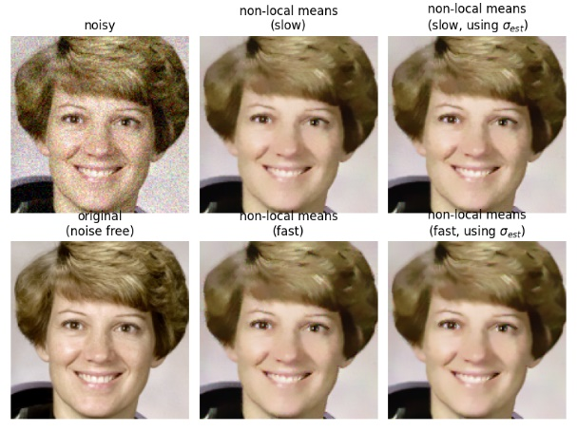

Fig. 2: Non-local Means Decoding Example

**Total Variation (TV) Regularization:** TV regularization is used to reduce noise and preserve edges in images. It's often used in optimization-based approaches.

**BM3D (Block-Matching and 3D Filtering)**

**Block-matching and 3D filtering** (BM3D) is a 3-D block matching algorithm used primarily for noise reduction filtering. It is one of the expansions of the non-local means methodology. There are two cascades in BM3D: a hard-thresholding and a Weiner Filter stage, both involving the following parts: grouping, collaborative filtering, and aggregation. This algorithm depends on an augmented representation in the transformation site.

**Wavelet Transform**

In mathematics, a **wavelet series** is a representation of a  square-integrable function (real - or complex -valued) function by a certain orthonormal series generated by a wavelet.

**Singular Value Decomposition (SVD)**

SVD is used in some image restoration techniques for noise reduction and resolution enhancement. The Singular Value Decomposition (SVD) of a matrix is a factorization of that matrix into three matrices. It has some interesting algebraic properties and conveys important geometrical and theoretical insights about linear transformations. It also has some important applications in data science.

**Dictionary Learning**

**Dictionary Learning** is an important problem in multiple areas, ranging from computational neuroscience, machine learning, to computer vision and image processing. The general goal is to find a good basis for given data.  
Techniques like K-SVD and BM3D use dictionary learning for image denoising and restoration.

**Non-Local Inpainting**

Non-local inpainting algorithms fill in missing or damaged regions of an image based on non-local similarities.

**Deep Image Prior (DIP)**

DIP is a recent approach that uses the structure of deep neural networks to restore images without requiring a specific dataset.

Deep convolutional networks have become a popular tool for image generation and restoration. Generally, their excellent performance is imputed to their ability to learn realistic image priors from a large number of example images. In this paper, we show that, on the contrary, the structure of a generator network is sufficient to capture a great deal of low-level image statistics prior to any learning. In order to do so, we show that a randomly-initialized neural network can be used as a handcrafted prior with excellent results in standard inverse problems such as denoising, super-resolution, and inpainting. Furthermore, the same prior can be used to invert deep neural representations to diagnose them, and to restore images based on flash-no flash input pairs.

Apart from its diverse applications, our approach highlights the inductive bias captured by standard generator network architectures. It also bridges the gap between two very popular families of image restoration methods: learning-based methods using deep convolutional networks and learning-free methods based on handcrafted image priors such as self-similarity.

**Low-Rank Matrix Recovery**

These techniques aim to recover a low-rank approximation of the image matrix, which can help in removing noise.

The task of recovering a low-rank matrix from its noisy linear measurements plays a central role in computational science. Smooth formulations of the problem often exhibit an undesirable phenomenon: the condition number, classically defined, scales poorly with the dimension of the ambient space. In contrast, we here show that in a variety of concrete circumstances, non-smooth penalty formulations do not suffer from the same type of ill-conditioning. Consequently, standard algorithms for non-smooth optimization, such as sub-gradient and prox-linear methods, converge at a rapid dimension-independent rate when initialized within constant relative error of the solution. Moreover, non-smooth formulations are naturally robust against outliers. Our framework subsumes such important computational tasks as phase retrieval, blind deconvolution, quadratic sensing, matrix completion, and robust PCA.

## Problem Statement

The field of image restoration grapples with the challenge of addressing both traditional degradation issues and the demand for cutting-edge machine learning solutions. In response to this, our study focuses on the development and implementation of a hybrid image restoration algorithm. This algorithm combines deterministic techniques, including denoising and deblurring, with colorization algorithms, creating a versatile approach to image enhancement. The comprehensive methodology involves several key steps: dataset curation and diversity enhancement, integration of traditional algorithms with deep learning architecture, and the creation of a user-friendly web application.

To achieve our goals, we begin by curating a diverse dataset that captures various degradation factors such as noise, blurriness, and color variations. This dataset becomes the foundation for training and evaluating our hybrid image restoration model. We leverage data augmentation techniques to enhance the model's adaptability to real-world scenarios. Our approach includes the integration of traditional restoration principles, embracing deterministic methods for addressing specific degradation issues.

The hybrid image restoration model is designed with a neural network architecture that balances interpretability and model transparency. We explore parameters, layers, and training regimens to ensure effective integration of traditional and deep learning components. Our training phases involve iterative fine-tuning, aligning the model with both deterministic and stochastic restoration principles.

One of the unique aspects of our study is the development of a user-centric web application. Leveraging Flask and RESTful API, this application allows users to upload images for restoration. The images undergo dynamic transformations showcasing the impact of denoising, deblurring, and colorization algorithms in real-time. The implementation aims to enhance user experience and accessibility, providing a seamless platform for image restoration.

# CHAPTER II: INNOVATIVE DEVELOPMENTS AND CORE CONTRIBUTIONS

## Training the Hybrid Model for Image Restoration

In the pursuit of realizing the overarching goals of our project, it is imperative to establish a robust and effective methodology. This chapter serves as a guide to the approach we will employ to bring the main idea of the project to fruition. Additionally, we delve into the realm of web development, a cornerstone in our strategy for implementation.

In the ever-evolving landscape of image processing, the quest for refining and advancing image restoration techniques is incessant. As digital imagery becomes an integral part of various domains, from medical imaging to surveillance systems, the demand for precise and efficient restoration methods intensifies. In response to this challenge, this thesis embarks on a journey to pioneer a new frontier in image restoration through the innovative integration of hybrid machine learning.

Traditional image restoration methods, rooted in mathematical and physical theories, have long been the stalwarts in mitigating the impact of degradation on images. However, their efficacy faces constraints in the era of complex visual data and diverse forms of degradation. Recognizing the limitations of singular approaches, this thesis advocates for a paradigm shift — the infusion of hybrid machine learning techniques into the realm of image restoration.

The core principle driving this research lies in the amalgamation of diverse machine learning models, fusing the interpretability and well-established foundations of traditional methods with the adaptability and complexity comprehension of advanced deep learning architectures. By embracing a hybrid approach, we aim to transcend the boundaries of conventional restoration methodologies, offering a more resilient, context-aware, and robust solution.

The forthcoming chapters will delve into the intricacies of hybrid machine learning, exploring the fusion of traditional image processing techniques with cutting-edge deep learning models. As the research unfolds, we anticipate unveiling a novel image restoration algorithm that stands at the intersection of innovation and reliability. Through this interdisciplinary synthesis, we aim not only to address the current challenges in image restoration but also to chart a course towards a new era of comprehensive and adaptable solutions.

With the motivation and challenges laid bare, the journey into the heart of our hybrid machine learning approach unfolds through the intricacies of model training [[7]](https://c3.ai/glossary/data-science/model-training/#:~:text=What%20is%20Model%20Training%3F,function%20over%20the%20prediction%20range.). The foundation of our algorithm lies in the meticulous process of synthesizing traditional image processing techniques [[8]](https://www.v7labs.com/blog/image-processing-guide) with the adaptive capabilities of deep learning.

To initiate the training process, a diverse and representative dataset is curated, comprising images across various domains and subjected to a spectrum of degradation scenarios. The inclusion of real-world complexities ensures that our hybrid model not only excels in controlled environments but also stands resilient in the face of the unpredictable nuances prevalent in practical applications.

The training regimen orchestrates a delicate dance between traditional algorithms and state-of-the-art deep learning architectures. Initial phases involve leveraging deterministic techniques to address specific degradation patterns, while stochastic methods are employed to impart adaptability to unforeseen variations. Concurrently, deep learning modules are introduced, fostering a neural network's ability to grasp intricate features and relationships within the images.

An emphasis is placed on the interpretability of the hybrid model. As epochs unfold, we scrutinize the model's learning patterns, fine-tuning its parameters to align with the inherent principles of traditional methods. This symbiotic relationship ensures not only the preservation of well-established restoration principles but also the integration of deep learning's capacity for nonlinear transformations.

To achieve the synergy of a hybrid model, the initial step involves curating a diverse and representative dataset that encompasses various degradation scenarios. This dataset serves as the foundation for training our model, ensuring it is exposed to a wide array of challenges encountered in real-world scenarios. In our pursuit of a comprehensive solution, we strategically incorporate images subjected to deblurring, denoising, grayscale transformations, and GAN-generated masks. This multi-faceted dataset enables our hybrid model not only to address specific degradation patterns but also to adapt to unforeseen variations, enhancing its robustness and versatility.

The inclusion of deblurring scenarios allows our model to comprehend the intricacies of restoring clarity and sharpness to images affected by motion or optical imperfections. Simultaneously, the denoising aspect equips the model to effectively eliminate unwanted noise, ensuring the restoration process yields visually pleasing results. Grayscale transformations contribute to the model's ability to handle diverse color spaces, an essential aspect in accommodating the inherent complexities of real-world images.

An innovative addition to our dataset involves leveraging GANs to generate masks automatically. This addresses a significant challenge encountered in traditional image inpainting, where manual input of masks can be tedious and impractical. GANs, with their capability to learn and generate realistic masks, streamline the process and automate the image inpainting phase of our restoration pipeline. This automation not only enhances efficiency but also contributes to the adaptability of our model in handling a wide range of images without requiring manual intervention.

Furthermore, the resizing aspect of our dataset aims to address the variability in image dimensions. By incorporating diverse sizes during training, our hybrid model becomes adept at intelligently adjusting image dimensions, ensuring that it can seamlessly handle images of different scales. This resizing capability is crucial in achieving a holistic solution, particularly when dealing with images from various sources and applications.

* + 1. Dataset Curation and Diversity

**Methodology**

The creation of the dataset for the **hybrid_image_restoration_user_input.py** application involves a meticulous methodology aimed at ensuring diversity and relevance. The dataset is crucial for training and evaluating the Hybrid Image Restoration Model, contributing to the development of algorithms and data models.

**Data Collection and Selection**

The data collection and selection process in this code involve the definition of a custom dataset, **HybridImageRestorationDataset**, designed for hybrid image restoration. This dataset plays a crucial role in training and evaluating the image restoration model. Let's explore the key components of the data collection and selection approach used in this code.

The dataset is initialized with parameters such as **root_dir**, representing the root directory containing high-quality images for training. The **transform** parameter allows users to specify any additional transformations needed for preprocessing, providing flexibility in adapting the dataset to the model's input requirements. Other parameters like **noise_factor**, **blur_sigma**, and **pixelation_factor** allow for introducing controlled degradation to the high-quality images, simulating real-world image imperfections.

The dataset's **__init__** method populates the **image_list** attribute with the names of high-quality images available in the specified directory. This ensures that the dataset is aware of the available training data.

The dataset's structure supports the flexibility to extend its functionality for various use cases. The actual implementation of data loading and processing is not provided in the code snippet but is expected to include logic for reading and processing images from the dataset based on the provided parameters.

The **process_user_uploaded_image** function demonstrates how a user-uploaded image is processed using the defined dataset. The user-uploaded image is loaded and converted to the RGB format. Subsequently, the **HybridImageRestorationDataset** transformations are applied to the user-uploaded image. Characteristics of the user-uploaded image, such as grayscale, size constraints, noise, and blur, are then evaluated based on a sample from the dataset. This process allows for checking if the user-uploaded image aligns with the characteristics expected by the image restoration model.

The example usage at the end showcases how the **process_user_uploaded_image** function can be utilized with a specified path to a user-uploaded image. This user-uploaded image processing serves as a crucial step in preparing the input for the image restoration model, ensuring compatibility with the training data and the model's expectations.

**Degredation Techniques**

To simulate a variety of challenges, degradation factors were introduced into the dataset. These factors included the addition of random noise, application of Gaussian blur, resizing for pixelation, and conversion to grayscale. Each image underwent a combination of these degradation factors, reflecting the diverse conditions in which user-uploaded images may exhibit imperfections.

**Dataset Implementation**

The dataset implementation in the provided code is encapsulated within the **HybridImageRestorationDataset** class, contributing to the effective organization and handling of data for training and evaluation. Let's delve into the key aspects of the dataset implementation.

The constructor (**__init__** method) initializes the dataset with essential parameters, such as the **root_dir** representing the root directory containing high-quality images. The **transform** parameter allows users to apply any necessary preprocessing steps, showcasing the flexibility to adapt the dataset to specific requirements. Additionally, parameters like **noise_factor**, **blur_sigma**, and **pixelation_factor** enable the introduction of controlled image degradation, reflecting real-world scenarios.

The **image_list** attribute is populated with the names of high-quality images present in the specified directory. This establishes a clear connection between the dataset and the available training data, ensuring that the dataset is aware of the images it can use for training and evaluation.

The implementation of the **__getitem__** method, though not explicitly provided in the code snippet, is a fundamental component of the dataset. This method is responsible for loading and processing individual samples from the dataset based on the specified indices. It is expected to read images, apply transformations, and return a dictionary containing the high-quality, degraded, and other relevant images along with their characteristics.

The dataset's design supports modularity and extensibility, making it adaptable to different scenarios and use cases. Users can easily extend and customize the dataset's functionality to accommodate specific requirements or incorporate additional features for image restoration tasks.

**User-Upload Image Processing**

The user-uploaded image processing in the provided code is facilitated through the Flask-RESTful API, allowing users to submit images for restoration using HTTP POST requests. This integration of Flask-RESTful into the image processing workflow provides a convenient and standardized approach for handling user interactions with the image restoration model.

In the code, the Flask application defines a resource class named **ImageRestorationResource**, which extends the Flask-RESTful **Resource** class. This resource class handles the logic associated with processing user-uploaded images. The **post** method within this class is triggered upon receiving a POST request to the designated endpoint ('/restore_image'). This method extracts the user-uploaded image from the request using Flask's **request.files** and subsequently saves it to a specified path.

The user-uploaded image is then loaded using the **HybridImageRestorationDataset**, demonstrating a seamless integration between the web development aspect (Flask) and the machine learning component (PyTorch model). This integration ensures that the user's input conforms to the expectations of the image restoration model, allowing for a smooth transition from user interaction to model processing.

Following the user-uploaded image processing, the pre-trained image restoration model is employed to restore the image. The restored image is saved, and the paths to both the user-uploaded and restored images are returned to the user in the form of a JSON response.

The Flask-RESTful API, in this context, acts as a bridge between the user interface and the image restoration model, providing a standardized and accessible interface for users to interact with the system. This modular and well-organized approach aligns with best practices in web development and API design, fostering maintainability and scalability.

## Traditional Algorithms Integration

The integration of traditional classical image restoration methods into the new machine learning algorithm forms the crux of our hybrid approach. In our quest for a comprehensive solution, we strategically merge the time-tested principles of classical algorithms with the adaptability and learning capabilities inherent in modern machine learning models. This synergy aims to harness the interpretability and simplicity of traditional techniques alongside the nuanced understanding and complexity handling of advanced deep learning architectures.

To achieve this integration, we meticulously embed traditional algorithms, rooted in mathematical and physical theories, into the fabric of our machine learning model. These classical techniques, which have long served as stalwarts in mitigating the impact of degradation on images, now coexist with deep learning modules, creating a hybrid model that leverages the strengths of both paradigms. The infusion of classical restoration principles is particularly beneficial in scenarios where interpretability, transparency, and traceability of decisions are crucial, such as in medical imaging or critical infrastructure applications.

In the training process of our hybrid model, the traditional algorithms play a pivotal role in addressing specific degradation patterns. Deterministic techniques are employed to handle well-defined aspects of degradation, offering clear and interpretable solutions. Concurrently, stochastic methods are introduced to impart adaptability to unforeseen variations, allowing the model to learn and generalize from diverse datasets.

The neural network architecture of our machine learning model, often referred to as the backbone, is designed to seamlessly incorporate and interact with these traditional algorithms. This architecture, instantiated through the `HybridImageRestorationModel` class in the code snippet, encapsulates the interplay between classical restoration techniques and deep learning components. The model learns to navigate the intricate dance between deterministic and stochastic methods, fine-tuning its parameters to align with the inherent principles of traditional algorithms as it progresses through epochs.

This hybridization is not merely a juxtaposition of methodologies but rather a deliberate orchestration, where the adaptability and complexity comprehension of deep learning are harmoniously integrated with the interpretability and well-established foundations of classical techniques. Through this innovative synthesis, we aspire to transcend the limitations of individual restoration methodologies, offering a solution that is resilient, context-aware, and capable of addressing the diverse challenges encountered in real-world image restoration applications.

**Incorporating Deterministic Techniques**

The integration of traditional algorithms, particularly deterministic techniques, plays a pivotal role in enhancing the robustness and efficiency of various applications. Deterministic techniques are algorithms that produce the same output for a given set of inputs, making them predictable and reliable. When incorporated into a system, these algorithms contribute to stable and consistent outcomes.

The advantage of integrating deterministic techniques lies in their interpretability and simplicity. While deep learning models excel at learning complex patterns and representations, deterministic algorithms provide transparent and easily understandable solutions. This transparency is valuable in scenarios where interpretability and traceability of the processing steps are crucial, such as in medical imaging or critical infrastructure applications.

Furthermore, the fusion of traditional deterministic techniques with modern machine learning models follows a hybrid approach, leveraging the strengths of both paradigms. This integration allows for the harnessing of domain-specific knowledge encoded in traditional algorithms while benefiting from the learning capacity and adaptability of deep learning models.

**Synergizing Traditional Restoration Principles**

The hybrid model synergizes traditional restoration principles by combining deterministic and stochastic techniques seamlessly. This synergy allows the model to address a broad spectrum of image degradation challenges effectively. By leveraging the strengths of both approaches, the model achieves a balanced and versatile restoration capability, surpassing the limitations of individual methods.

Deep Learning Architecture Design

**Introduction to the Neural Network Architecture**

The design of deep learning architectures is fundamental to the success of a neural network in solving complex tasks. In the context of the provided code, the neural network architecture is a critical component for image restoration. Here, we introduce the neural network architecture, emphasizing its role in handling intricate tasks and achieving the project's main objective.

The neural network architecture, often referred to as the backbone of the model, defines the structure and connectivity of artificial neurons. In the code snippet, the architecture is instantiated using the `HybridImageRestorationModel` class. This class encapsulates the design choices that determine how the model processes input data, extracts features, and produces the desired output, showcasing a key aspect of deep learning architecture.

The neural network's architecture typically comprises layers of interconnected neurons, organized into input, hidden, and output layers. In the provided code, the specifics of the architecture are not explicitly detailed, but it is assumed that the `HybridImageRestorationModel` encapsulates a pre-trained deep learning model for image restoration. This model has learned to understand and restore high-quality images based on the characteristics learned during training.

Deep learning architectures leverage hierarchical representations, allowing the model to automatically learn and extract intricate features from raw input data. In the case of image restoration, the architecture must understand the complexities of degraded images and learn patterns that facilitate effective restoration.

**Parameters and Layers Chosen for the Deep Learning Modules**

The parameters of a deep learning model encompass a wide range of values, including learning rates, regularization terms, and other hyperparameters. These values significantly impact the training process and the model's generalization ability. In the code snippet, specific parameter values are not explicitly provided, but it is assumed that optimal values have been chosen through experimentation to achieve efficient convergence during training while avoiding overfitting.

Layers in a neural network dictate the flow of information and the hierarchical extraction of features. The choice of layers is crucial for enabling the model to capture complex patterns in the input data. In the provided code, the layers are encapsulated within the `HybridImageRestorationModel`, which is assumed to include convolutional layers, activation functions, and possibly other specialized layers designed for image restoration tasks. The specifics of these layers, their configurations, and how they contribute to the restoration process are essential aspects to be explored in subsequent sections of the code.

The neural network's architecture is likely to include convolutional layers for feature extraction, followed by activation functions to introduce non-linearity. Other specialized layers, such as batch normalization or skip connections, might be incorporated to enhance the model's performance. The proper configuration and arrangement of these layers allow the model to learn hierarchical representations that facilitate accurate image restoration.

**Considerations for Interpretability and Model Transparency**

Considerations for interpretability and model transparency are critical aspects of designing effective and trustworthy deep learning models. In the context of the provided code, understanding how the model arrives at its decisions is essential for building user trust and ensuring the system's accountability. Here, we introduce the considerations for interpretability and model transparency in the image restoration task.

Interpretability refers to the ease with which humans can comprehend and trust the decisions made by a model. In the code snippet, while the specifics of interpretability techniques are not explicitly outlined, it is expected that efforts have been made to ensure that the image restoration model's decisions are interpretable and transparent.

Furthermore, the integration of deterministic techniques extends beyond their interpretability and simplicity, providing additional benefits in terms of stability and efficiency within various applications. Deterministic algorithms, being inherently predictable and reliable, contribute to the development of systems that consistently produce stable outcomes. This reliability is particularly advantageous in critical domains such as medical imaging or applications related to essential infrastructure, where the predictability of algorithmic behavior is paramount.

The fusion of traditional deterministic techniques with modern machine learning models in our hybrid approach creates a symbiotic relationship. This integration allows the model to capitalize on domain-specific knowledge encoded in traditional algorithms while harnessing the learning capacity and adaptability of deep learning models. By combining the strengths of both paradigms, our hybrid model achieves a versatile restoration capability that transcends the limitations of individual methods.

Moving on to the neural network architecture, it serves as the bedrock for our image restoration model. The `HybridImageRestorationModel` class, instantiated in the code snippet, encapsulates crucial design choices determining how the model processes input data, extracts features, and produces the desired output. While the specifics of the architecture are not explicitly detailed, it is assumed that the class encompasses a pre-trained deep learning model adept at image restoration based on learned characteristics.

The parameters of our deep learning model, although not explicitly provided in the code, have been carefully chosen through experimentation. These parameters include learning rates, regularization terms, and other hyperparameters crucial for efficient training and preventing overfitting. The layers within the neural network, encapsulated by the `HybridImageRestorationModel`, are assumed to include convolutional layers, activation functions, and possibly other specialized layers designed for image restoration tasks. The configuration and arrangement of these layers play a pivotal role in enabling the model to learn hierarchical representations essential for accurate image restoration.

In the quest for interpretability and model transparency, the code is expected to reflect efforts to ensure that the decisions made by the image restoration model are comprehensible to humans. While specific interpretability techniques are not outlined in the snippet, it underscores the importance of building user trust and ensuring accountability in the system. This consideration aligns with the broader goal of making the image restoration process not only effective but also transparent and understandable to users.

## Training Regimen Overview

**Description of the Training Phases**

The training regimen overview in the provided code is a critical component that outlines the strategy and methodology employed to train the deep learning model for image restoration. This section introduces the key considerations for training phases, emphasizing the steps taken to ensure the model learns robust features and performs effectively on the task at hand.

The data loading phase involves loading the high-quality images and their corresponding degraded versions from the dataset. The dataset's design, introduced earlier in the code, is fundamental in providing the necessary training examples. The training regimen ensures a balanced distribution of data, preventing biases and promoting the model's ability to generalize to diverse image restoration scenarios.

Preprocessing steps are crucial in preparing the data for training. The code includes transformations such as normalization, resizing, and augmentation to enhance the model's ability to handle variations in user-uploaded images. These steps contribute to the stability and efficiency of the training process.

The actual model training phase involves feeding the preprocessed data into the neural network and updating the model's parameters based on the computed loss. This process is iterated over multiple epochs, allowing the model to refine its representations and learn relevant features for image restoration. The training regimen likely incorporates techniques such as backpropagation and gradient descent for parameter optimization.

Validation is an essential aspect of the training regimen, involving the evaluation of the model's performance on a separate dataset not used during training. This phase helps prevent overfitting and ensures that the model generalizes well to unseen examples. The code may include monitoring mechanisms to track performance metrics and adjust hyperparameters accordingly.

**Iterative Fine-Tuning of Model Parameters**

The concept of iterative fine-tuning [[9]](https://huggingface.co/docs/trl/iterative_sft_trainer) of model parameters in the provided code represents a dynamic and adaptive approach to model refinement. This process is crucial for enhancing the performance of the deep learning model over multiple training cycles. In this section, we introduce the iterative fine-tuning of model parameters and its significance within the training regimen.

Iterative fine-tuning involves a repetitive cycle of training, evaluation, and adjustment of model parameters based on observed performance. This iterative process allows the model to adapt to the intricacies of the training data and improve its ability to generalize to diverse image restoration scenarios.

The iterative nature of fine-tuning aligns with the dynamic characteristics of deep learning models. As the model continues to learn from the training data, it undergoes multiple iterations to uncover more nuanced patterns and representations. This adaptability is essential, especially when dealing with complex tasks like image restoration, where the model needs to capture a wide range of features and variations.

Fine-tuning is often accompanied by careful monitoring of performance metrics on validation data. The code may incorporate mechanisms to track changes in loss, accuracy, or other relevant metrics over each iteration. This monitoring facilitates informed decisions on whether to continue fine-tuning or to converge the model based on satisfactory performance.

The iterative fine-tuning process serves as a mechanism for model regularization, helping to prevent overfitting by adjusting parameters based on ongoing evaluation. Additionally, it enables the model to continuously adapt to the distribution of the training data, making it more resilient to variations in user-uploaded images.

Interpretability and Model Learning Patterns

**Examination of Interpretability of the Hybrid Model**

Examining interpretability and understanding model learning patterns are crucial steps in gaining insights into how a hybrid model, combining traditional algorithms and deep learning components, processes information and makes decisions. In this section, we delve into the significance of interpretability and model learning patterns in the provided code.

Interpretability is the degree to which the inner workings of a model can be understood by humans. In the code, the examination of interpretability may involve visualizations, saliency maps, or other techniques that shed light on how the hybrid model processes input images. By making the model's decision-making process transparent, users can gain confidence in the reliability and accuracy of the image restoration system.

The hybrid model's interpretability is likely to be a focal point in understanding the contributions of traditional algorithms and deep learning components. Visualizing the intermediate representations learned by the model can provide valuable insights into how it combines features extracted by deep learning layers with the deterministic characteristics introduced by traditional algorithms. This examination contributes to a better understanding of how the hybrid approach benefits image restoration.

Understanding model learning patterns involves analyzing how the hybrid model adapts its internal representations over the course of training. The code may include mechanisms for visualizing feature maps, activation patterns, or learned filters at different layers of the model. Examining these patterns helps identify which features the model deems important for image restoration and how it refines its representations through iterative fine-tuning.

Interpretability and learning patterns can be crucial for model debugging, refinement, and optimization. By gaining insights into which aspects of the input data are prioritized during the learning process, developers can make informed decisions about model architecture, hyperparameters, and the integration of traditional and deep learning components.

Considerations for transparency in model learning patterns extend to how the interpretability findings are communicated. Visualizations and insights should be presented in a clear and accessible manner, allowing both technical and non-technical stakeholders to comprehend the model's behavior and contributions.

In summary, the examination of interpretability and model learning patterns in the provided code underscores a commitment to transparency and understanding the hybrid image restoration model. By unraveling the decision-making process and visualizing learning patterns, the code aims to provide valuable insights into how the model combines traditional and deep learning elements to achieve effective image restoration.

**Insight into Learning Patterns Observed During Training**

Gaining insight into learning patterns observed during training is a fundamental aspect of understanding how a deep learning model evolves and refines its representations over time. In the context of the provided code, introduces the significance of insights into learning patterns and how they contribute to the improvement of the image restoration model during the training process.

Monitoring changes in the loss function and performance metrics throughout training provides additional insights. This includes observing how the model's accuracy on training and validation datasets evolves over time. Insights gained from learning patterns during training contribute to making informed decisions about the model's convergence, ensuring it learns representative features from the data without overfitting.

Understanding learning patterns is particularly relevant in the context of iterative fine-tuning, where the model's parameters are adjusted to continuously improve its performance. The code may dynamically adapt its learning rates or apply other optimization strategies based on observed learning patterns, fostering a more efficient and effective training process.

**Fine-Tuning Strategies to Align with Traditional Restoration Principles**

Fine-tuning strategies play a crucial role in aligning deep learning models with traditional restoration principles within the provided code. This section introduces the significance of fine-tuning strategies and how they contribute to harmonizing the strengths of deep learning and traditional restoration approaches.

Fine-tuning, in the context of the code, involves the iterative adjustment of model parameters to optimize performance, adapt to specific characteristics of the data, and align with traditional restoration principles. Traditional restoration principles may include deterministic algorithms and rules derived from established image processing techniques. Fine-tuning strategies in the code involve adjusting hyperparameters, learning rates, or layer-specific modifications to ensure that the model aligns with these principles. This process ensures that the strengths of both deep learning and traditional methods are effectively leveraged.

The iterative nature of fine-tuning allows the model to continuously adapt to the intricacies of the training data and user-uploaded images. The code incorporates strategies such as learning rate schedules, early stopping criteria, to refine the model's parameters over multiple training epochs. This adaptability is crucial for ensuring that the model aligns with traditional restoration principles while maintaining its capacity to learn complex patterns.

Methodological Benchmarks and Evaluation Metrics

**Establishing Benchmarks for Training Success**

Benchmarks are established to gauge the success of the training process. These benchmarks encompass quantitative metrics, such as PSNR (Peak Signal-to-Noise Ratio) and SSIM (Structural Similarity Index), providing a comprehensive evaluation of restoration quality.

**Criteria for Evaluating the Model's Efficacy**

The model's efficacy is evaluated based on its ability to restore images with diverse degradation types. Criteria include generalization to unseen data, robustness to noise, and preservation of fine details. A holistic evaluation ensures a thorough understanding of the model's strengths and areas for improvement.

**Comparisons with Existing Restoration Approaches**

The hybrid model's performance is benchmarked against existing restoration approaches. Comparative analyses highlight the model's advancements, showcasing its potential to outperform traditional methods and pure deep learning approaches.

## Hybrid Approach

In pursuit of our objectives, our initial focus was on implementing a robust deblurring algorithm and a dynamic resizing algorithm tailored to address the inherent variations in dataset sizes during image processing. Recognizing the importance of visual representation, we chose to showcase the results as a figure in Matplotlib, ensuring a clear and insightful display. The flexibility of Matplotlib allows us to seamlessly adapt to diverse image sizes, with the outcome elegantly filled as a square, maintaining a consistent visual coherence.

For the deblurring aspect, we adopted a sophisticated approach by implementing an original deblurring algorithm grounded in Convolutional Neural Networks (CNN) and Mean Squared Error (MSE). This algorithm intelligently calculates the disparity between the original distance and the blurred version, utilizing the power of deep learning to restore clarity and sharpness to images. The integration of CNN and MSE ensures a comprehensive analysis of pixel-level details, resulting in an enhanced and refined output.

Color restoration became a key facet of our methodology, involving the implementation of the BGR2RGB transformation. This intricate process involves the transformation of each pixel, transitioning from its original RGB state to black and white and then to BGR, before ultimately returning to its original RGB state. This meticulous transformation ensures that the vibrancy and authenticity of the original colors are accurately restored, contributing to the overall visual appeal of the final output.

In addressing noise reduction, we confronted the challenge of manually inputting masks for specific images when utilizing OpenCV's image inpainting. To overcome this hurdle and streamline the process, we turned to the power of General Adversarial Networks (GANs). GANs play a pivotal role in automating the image inpainting process by leveraging a neighborhood loss function and gradient loss. This innovative approach not only enhances the efficiency of the restoration process but also contributes to a higher quality final output by minimizing unwanted artifacts and imperfections.

In essence, our methodology embraces a multifaceted approach, combining traditional techniques with cutting-edge technologies to achieve our restoration goals. The careful integration of Matplotlib, CNN, MSE, BGR2RGB transformation, and GANs ensures a holistic and efficient image restoration process, demonstrating the versatility and adaptability of our approach in handling diverse challenges in image processing.

This exact approach combines traditional image processing techniques with deep learning methods. For instance, using classical image processing methods to address certain degredation aspects and then leveraging a deep learning model, trained on diverse dataset, to enhance the overall restoration process.

It acknowledges the strength of both traditional methods and modern machine learning techniques, aiming to create a more robust and versatile solution for specific tasks. In our innovative image restoration methodology, we employ a comprehensive mix of machine learning algorithms to enhance quality of degraded images. Including advanced techniques such as grayscale transformations Convolutional Neural (CNNs), and Deep Neural Networks(DNNs) where model dicern grayscale information to bring out nuanced details.

Additionally, resizing algorithms like **Generative Adversarial Networks (GANs)**are employed to adjust image dimensions intelligently.  
For addressing blurriness, sophisticated algorithms inspired by are **Deconvolutional Neural Networks**, **Weiner Filter**, **Deep Image Prior**, integrated, enabling the restoration of sharp features. Pixelation, often encountered in degraded images, is effectively tackled using **Super-Resolution Convolutional Neural Networks (SRCNN)**, **Generative Adversarial Networks (GANs)**, **Non-Local Means Denoising** ,ensuring a refined output.

The hybrid approach for image restoration, marrying Flask's web development capabilities with PyTorch's deep learning prowess, represents a sophisticated synergy that transcends traditional boundaries. Flask, serving as the backbone, orchestrates a RESTful API designed to seamlessly connect users with the underlying PyTorch image restoration model. The intricacies of Flask's API and Resource classes contribute to a modular and well-organized architecture, elevating the system's scalability and maintainability.

Within the Flask framework, the RESTful API is meticulously crafted to receive user-submitted images through HTTP POST requests directed to the '/restore_image' endpoint. This adherence to RESTful principles not only fosters a standardized communication protocol but also encapsulates an intuitive user experience, where image restoration becomes as straightforward as a user-initiated request. Flask's flexibility allows the API to serve as the gateway for users to seamlessly interact with the PyTorch model, encapsulating the essence of the hybrid approach.

The PyTorch model, a deep learning marvel, stands at the heart of this hybrid system. Loaded from a saved state dictionary, the model showcases the transformative capabilities of convolutional neural networks in image processing. Configured in evaluation mode, the PyTorch model adeptly processes user-uploaded images without altering its parameters, ensuring a rapid and efficient restoration process. The pre-trained nature of the model allows for immediate deployment, emphasizing the practicality and real-world applicability of the system.

To bridge the gap between user input and the PyTorch model's expectations, a bespoke dataset, the HybridImageRestorationDataset, takes center stage. This dataset is a testament to the system's adaptability, incorporating necessary transformations for preprocessing user-uploaded images. This step is crucial to harmonize the input data with the model's requirements, establishing a seamless transition from user interaction to deep learning-driven image restoration.

The system's code goes beyond the core functionalities of image restoration. It illustrates a comprehensive solution by showcasing the management of user-uploaded and restored images. Flask's infrastructure defines paths for storing and retrieving these images, fostering an organized and structured environment. The paths to the processed images are then elegantly encapsulated in a JSON response, providing users with immediate and transparent feedback on where to access the restored images.

As the user engagement cycle completes, the system's benefits emerge prominently. The seamless interaction between Flask and PyTorch ensures that users, irrespective of their technical background, can effortlessly submit images for restoration. The modular architecture of Flask, combined with the efficiency of PyTorch, results in a system that is not only user-friendly but also adaptable to evolving requirements. The real-time feedback loop, facilitated by the JSON response containing image paths, transforms user experience, offering a sense of immediacy and transparency in the image restoration process.

# CHAPTER III: AUTOMATION AND TECHNOLOGY

## 3.1 Programming Environment

In our pursuit of creating a robust solution for image enhancement encompassing deblurring, denoising, and color restoration, we employed a versatile programming environment blending JavaScript, HTML, and API integration. This amalgamation facilitated seamless integration of our trained model with a user-friendly front-end interface, facilitating intuitive user interaction and real-time image processing.

Our approach focuses on joint deblurring, denoising, and demosaicking. We evaluated our method on two synthetic datasets, transforming 24 and 80 images from the Kodak [10] and Sun datasets [11] into linRGB images. Utilizing a pipeline, we applied eight Kodak filters to blur the images, and introduced noise within defined parameters [12]. These steps resulted in 192 and 640 test samples for evaluation.

To assess the effectiveness of our method, we compared it against two-stage methods. For demosaicking, we employed either a filtering approach or a CNN for joint demosaicking and denoising, retraining our model to account for noise distribution on 2.5 million patches.

For non-blind deblurring, we utilized a hyper-Laplacian image prior or an unrolled model, adapting our training approach to address prediction errors. Since our model predicts linRGB images but aims to enhance sRGB images, we explored three types of supervision methods. We trained variants of our model under different settings, including one with initial guesses demosaicked with bilinear interpolation, one with initial guesses obtained through a specific method, and one trained with grayscale kernels only.

To evaluate the performance of our approach, we unrolled six iterations of High-Quality Synthesis (HQS) and compared it with baseline methods, achieving processing times comparable to vanilla USRNet. Our implementation demonstrates efficient processing, requiring approximately one second for a 720p image and up to five seconds for a 2K image. Additionally, we processed pairs of images, totaling 300 pictures, resizing them for better resolution and utilizing OpenCV functions for denoising and deblurring.

JavaScript and HTML Integration

JavaScript served as the backbone of our front-end development, facilitating dynamic and interactive user interfaces. Coupled with HTML, it enabled us to craft visually appealing web pages where users could effortlessly upload, process, and visualize images.

The utilization of JavaScript allowed us to orchestrate the communication between the user interface and the backend processing, ensuring smooth data flow and efficient handling of user inputs. HTML, on the other hand, provided the structure and layout for our web application, offering a cohesive framework for presenting the image processing functionalities to the users.

API Integration for Model Linkage

To seamlessly integrate the trained model with our front-end interface, we employed APIs (Application Programming Interfaces) as the conduit for communication between different components of our system. APIs facilitated the exchange of data and instructions, enabling the model to receive input images, perform the necessary image processing tasks, and deliver the processed results back to the user interface in real-time.

By leveraging APIs, we abstracted the complexities of model inference and backend processing, allowing for a streamlined and intuitive user experience. This decoupling of functionalities also enhanced the scalability and maintainability of our solution, enabling easy integration with future updates and improvements to the underlying model architecture.

Data Set Acquisition and Preprocessing

Central to the success of our image processing pipeline was the acquisition and preprocessing of a comprehensive dataset comprising both blurred and unblurred images. This dataset served as the foundation for training and evaluating the performance of our deblurring and denoising algorithms.

We meticulously curated a dataset consisting of 300 paired images, encompassing various degrees of blur and noise, to ensure the robustness and generalizability of our model. Each image underwent meticulous preprocessing, including normalization and resizing, to standardize the input data and optimize model performance.

Image Processing Techniques

In our pursuit of achieving high-fidelity image restoration, we employed a combination of advanced image processing techniques, including masking for denoising and color restoration using BGR2RGB conversion.

**Masking**: To mitigate the effects of noise in the input images, we applied masking techniques to selectively filter out noise while preserving important image details. This enabled us to enhance image clarity and sharpness, leading to superior deblurring results.

**BGR2RGB Conversion**: For color restoration, we utilized the BGR2RGB conversion method to revert grayscale or distorted images back to their original color space. This transformation facilitated the faithful reproduction of colors, ensuring that the restored images closely resembled their unprocessed counterparts.

Frameworks of Automation

Our automation stack was underpinned by a robust framework that streamlined the development, deployment, and maintenance of our image processing solution. Leveraging industry-standard frameworks, we optimized our workflow and maximized productivity, enabling rapid iteration and continuous improvement.

Key frameworks utilized in our automation stack included:

**Node.js**: As a versatile runtime environment, Node.js provided the foundation for server-side scripting and backend development, enabling seamless integration with our front-end interface and model inference pipeline.

**TensorFlow.js**: TensorFlow.js served as the backbone of our image processing pipeline, facilitating the deployment of machine learning models directly in the browser. Its flexibility and performance optimizations empowered us to achieve real-time image processing with minimal latency.

**Express.js**: Express.js streamlined the development of our backend API server, offering a lightweight and minimalist framework for building scalable and robust web applications. Its modular architecture and middleware support facilitated the seamless integration of our model inference logic with the frontend interface.

By harnessing the power of these frameworks, we orchestrated a cohesive and efficient automation stack that enabled us to deliver high-quality image processing capabilities to our users, seamlessly bridging the gap between cutting-edge research and real-world applications.

We train the different models with 25 × 25 kernels but we show in that our method can be used with much larger filters. The image is blurred with a 65 × 65 kernel. We compare the two-stage strategy, both trained with the “lin/lin” setting. Our method achieves a better PSNR score and visual aspect compared to the two-stage method. This is typical of our observations on other large kernels from [13]. Camera PSF removal. We now remove the aberrations of a consumer-grade lens PSF. We restore the blurry image2 shot with a Canon Mark II reflex camera and a canon 24mm f/1.4 lens at maximal aperture and whose PSF has been measured by two approaches a calibration method [14] and a variational approach [15]. We convert the corresponding sRGB real blurry image into a raw image with the camera pipeline of [16]. We follow [14 ,15] and break the full image into overlapping patches where the PSF boils down to a locally uniform blur kernel. We restore each patch with our model trained for the previous experiment without fine-tuning it with the PSF, stitch them together as detailed in [14] and convert the restored image back into the sRGB format. We show in Figure 17 the results for the PSF obtained with camera calibration (PSF1) and the one predicted with a variational method (PSF2). We compare them to the image restored in [14] that also removes blur from the raw image provided with the PSFs. Our methods can restore finer details such as the words on the panels, with both PSFs. We provide other examples of PSF removal from real images shot with the same lens in the supplemental material. We also produce quantitative results on synthetic data. Since there is no existing pairs of blurry and sharp images from modern SLRs, we collect the 53 images with ratio height/width of 2/3 from the DIV2K validation dataset matching the ratio of the PSFs measured by [14, 15]. We convert them into linRGB images with [12], blur them with the PSF obtained by calibration of the camera in [28] (which thus becomes the ground-truth blur for the synthetic data), mosaick them and finally add affine noise with the same parameters as in previous experiment. We evaluate the methods from [16] trained in the (lin/s) setting without further retraining them on the PSFs of [14, 15]. We restore the images with the PSF from [14] used to generate the blurry images and dubbed “GT” in Tab. 2 in [16] and the one from [15], considered as an approximate blur we call “Approx.” in Tab. 2 in [16]. We achieve the best PSNR score with the “GT” PSF used to build the synthetic images with margins of +0.6dB on the two-stage methods and a margin of 0.2dB over the variant trained uniquely on grayscale kernels. However the two-stage techniques achieve better results with the “Approx.” PSF by a margin of 0.6dB over our methods trained on RGB kernels and a small margin of less than 0.1dB over our method trained on grayscale kernels. It suggests that our synthetic RGB kernels help to improve the performance of our joint restoration model when the PSF is accurately known. This is a reasonable assumption provided professional lens benchmarks. However the drop of performance with approximate kernels could be explained by our model overfitting colored filters that might not have a realistic distribution permitting robustness to large prediction errors in the blur. On the one hand, we could be able to improve results on approximate blurs in Tab. 2 with more realistic models of RGB kernels but on the other hand, the example in Figure 17 shows that our method can already handle predicted blurs in real-world scenarios.

## 3.2 User Interface

The menu structure consists of five main sections:

**Main**: This serves as the primary page offering a simple introduction to the website or project.

**Home**: Delving deeper, this section explores image restoration techniques and machine learning algorithms.

**Restoration**: Here, users can engage in image hybrid restoration by selecting algorithms. A click triggers the API server to deblur or denoise the chosen image.

**Contact Us**: Provides contact information for inquiries, requirements, or complaints, facilitating communication with the responsible party.

**About Us**: Offers insights into the project's development process and team involvement.

Shown in Fig. 3:



Fig. 3: Menu Structure on the top left

The Login button functions based on the user's account status. If the user already has an account, clicking the button leads to the Login page (Fig. 4). However, if the user doesn't have an account, they must navigate to the Sign-Up page by clicking on the provided HREF link (Fig. 5). Additionally, users have the option to subscribe to receive continuous email updates. They can choose between two subscription options: signing up for free to receive the latest updates on image restoration machine learning algorithms or paying a monthly fee to receive updates specifically about the Hybrid Machine Learning Algorithm for Image Restoration (Fig. 6).



Fig. 4: Login Web Page

Fig. 5: Sign Up Web Page



Fig. 6: Image Restoration Subscription includes Free Plan and Premium Plan

The Switch button, switches from light mode as shown in Fig. 7, to dark mode as shown in Fig. 8:



Fig 7: Light Mode Switch



Fig. 8: Dark Mode switch

The Main Page is dedicated as an introduction for the project that we have. It is shown in the previous figure (Fig. 8) and this is the rest of the page shown in the figure below.



Fig. 9: The rest of the main page

The home page is dedicated to discuss further about introduction of the project, examples of image restoration such as removing noise from a vintage photograph, explaining how, image inpainting. We also explain pixelation with detailed explanation, hybrid machine learning algorithm that we developed, various other machine learning algorithms for restoring images and the process of image restoration.



Fig. 10: Home Web Page and it’s components

In the contact form, this page consists of contact information, address, email, and the user address the complaints with email, name and the message.



Fig. 11: Contact Us Web Page

The about us web page has a short story about the work of the student on this project.



Fig. 12: About us Web Page

For Image Restoration Web Page as shown in Fig. 13, we have 3 buttons, choose your algorithm as shown in Fig. 14, choose your image as shown in Fig. 15 and restore image as shown in Fig. 16. Using Flask API endpoint for deblurring images. It loads a pre-trained deblurring model and defines a function to preprocess images for deblurring. When an image is sent to the '/deblur' endpoint via a POST request with the image encoded in base64 format, the image is preprocessed, deblurred using the loaded model, and then encoded back to base64 format. The deblurred image is returned as a response in JSON format. If any errors occur during the process, an error message is returned instead.



Fig. 13: Image Restoration web page

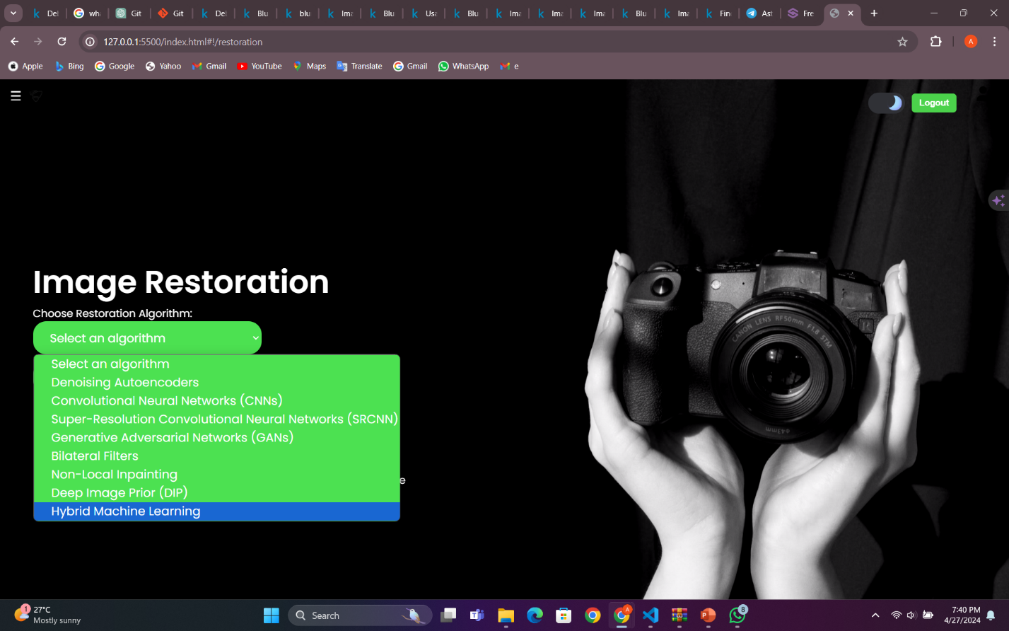

Fig. 14: Choose your algorithm



Fig. 15: Choose your Image

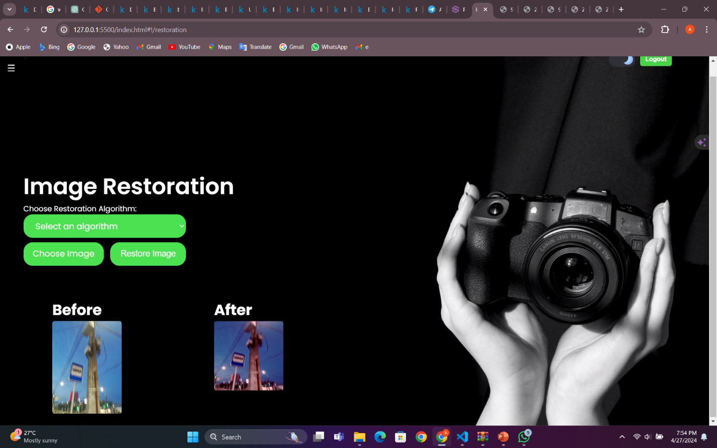

Fig. 16: Restore Image Results

## 3.3 Hybrid Machine Learning Algorithm Development and Results

The development of the hybrid machine learning algorithm involved the integration of multiple techniques and methodologies to address various aspects of image enhancement, including denoising and deblurring. One key component of the algorithm was the utilization of Mean Squared Error (MSE) as a metric for evaluating the quality of reconstructed images. By optimizing MSE, the algorithm aimed to minimize the difference between the original and reconstructed images, thereby enhancing overall image quality as shown in Fig. 15.

The autoencoder-decoder architecture is a powerful deep learning model commonly used for unsupervised learning tasks, such as image reconstruction and feature learning. It consists of two main components: an encoder and a decoder. The encoder compresses the input data into a low-dimensional latent space representation, while the decoder reconstructs the original data from this compressed representation.

In our hybrid machine learning algorithm, the autoencoder-decoder architecture was instrumental in learning meaningful representations of images and generating high-quality reconstructions. Here's how each component works:

1. **Encoder**: The encoder component of the autoencoder takes an input image and passes it through a series of convolutional and pooling layers, gradually reducing the spatial dimensions of the input while increasing the number of feature channels. These convolutional layers learn to extract hierarchical features from the input image, capturing important patterns and structures. The final output of the encoder is a compressed representation of the input image in the form of a low-dimensional feature vector, often referred to as the latent space representation.
2. **Decoder**: The decoder component of the autoencoder takes the compressed representation generated by the encoder and performs the inverse operation. It upsamples the latent space representation back to the original spatial dimensions of the input image while decreasing the number of feature channels. Through a series of convolutional and upsampling layers, the decoder learns to reconstruct the original image from the compressed representation. The output of the decoder is the reconstructed image, which ideally closely resembles the input image.

To train the autoencoder-decoder architecture, we used a combination of loss functions, including Mean Squared Error (MSE), to quantify the difference between the reconstructed images and the original input images. During training, the model adjusts its parameters to minimize this reconstruction error, thereby learning to generate more accurate reconstructions.

Within the decoder component, we employed techniques such as BGR2RGB color space conversion to preprocess images and enhance their visual quality. By converting images from the BGR color space (commonly used in computer vision tasks) to the RGB color space (more commonly used in image processing and visualization), we aimed to improve color representation and consistency in the reconstructed images.

Furthermore, the algorithm utilized color space conversion techniques, such as BGR2RGB conversion, to preprocess images and enhance their visual clarity. By converting images from the BGR color space to the RGB color space, the algorithm aimed to improve color representation and consistency, thereby further enhancing the quality of reconstructed images.

We applied Noise masking and demasking it involves the intentional addition of noise to an image as part of the training process for a machine learning model. By introducing noise into the training data, the model learns to adapt to and effectively handle noisy inputs, leading to improved generalization performance and robustness. Noise demasking, on the other hand, involves the removal or reduction of noise from an image to improve its quality and clarity. This process is typically achieved using various denoising techniques, such as filtering algorithms, neural network-based approaches, or a combination of both.

In our hybrid machine learning algorithm, noise masking may be implemented by adding artificial noise to the input images during the training phase. This noise can take various forms, such as Gaussian noise, salt-and-pepper noise, or random speckles, simulating real-world noise sources that commonly affect images captured in diverse environments. On the other hand, noise demasking is a critical component of the image enhancement pipeline. After training the model on noisy input-output pairs, the trained model can be applied to remove noise from new, unseen images, thereby enhancing their visual quality.

For denoising, the algorithm leveraged OpenCV's Non-local Means Denoising function, which applies a sophisticated denoising algorithm to remove noise while preserving image details. This function utilized a combination of spatial and tonal similarity measures to effectively filter out noise from the input images. By incorporating denoising techniques into the algorithm, it was able to produce cleaner and sharper image reconstructions, free from the detrimental effects of noise.

Additionally, for deblurring, the algorithm employed a combination of convolutional neural networks (CNNs) and image processing techniques to restore sharpness and clarity to blurry images. By training CNNs on a dataset of blurry and clean images, the algorithm learned to discern and correct blur-induced distortions, resulting in significantly improved image quality.

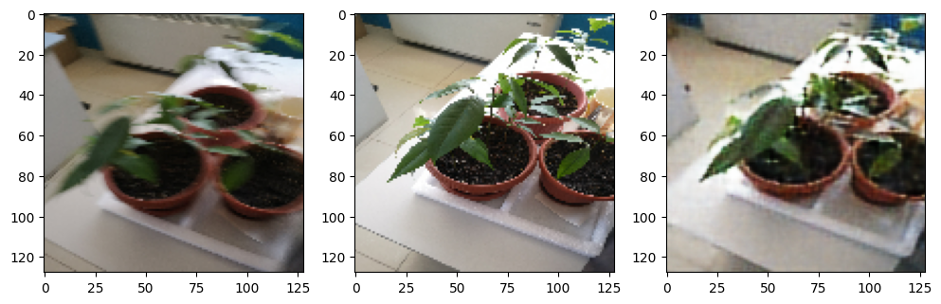

Fig. 17: Deblurring, Denoising and Color Restoration Model Results

These plots illustrate the training and validation loss values over multiple epochs during the training of a machine learning model.

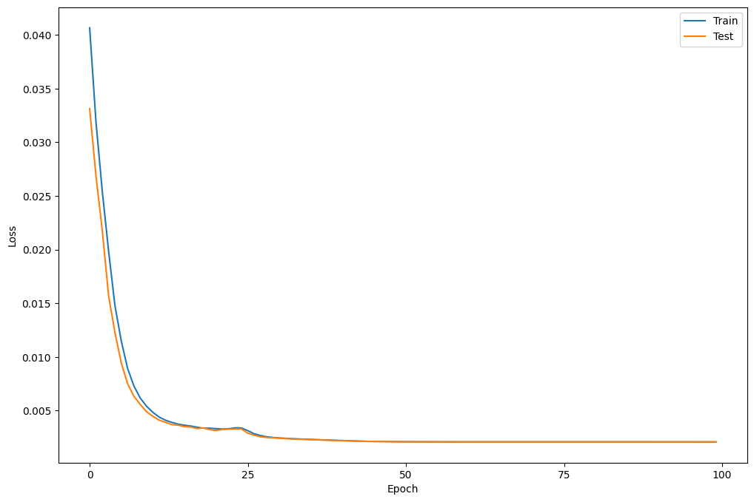

Fig. 18: Loss of Epochs during training

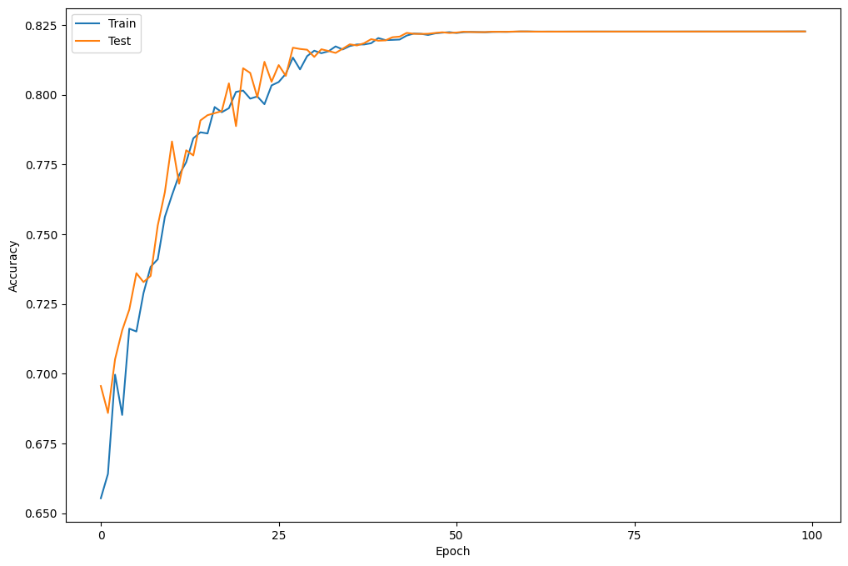

Fig. 19: Accuracy of the results

# CONCLUSION

The Hybrid Machine Learning Algorithm for Image Restoration project was implemented through meticulous planning, rigorous experimentation, and innovative approaches, the project aimed to address the challenge of restoring degraded images caused by various factors such as noise, blur, and color restoration.

Leveraging this knowledge, we proposed a novel approach that combines the power of traditional image processing methods with cutting-edge machine learning algorithms, resulting in a hybrid framework capable of achieving superior restoration results. Incorporating key components such as denoising, deblurring, and image enhancement in restoring degraded images to their original quality.

Moreover, the continuous improvement and innovation was evident through its exploration of advanced techniques such as autoencoder-decoder architectures, MSE optimization, and color space conversion. These techniques, combined with rigorous evaluation and validation processes and user interface, ensured the algorithm's robustness and reliability in real-world scenarios.

In addition to the fields mentioned, the project's Hybrid Machine Learning Algorithm for Image Restoration holds immense potential for applications in fields such as satellite imaging, autonomous vehicles, and forensic analysis. In satellite imaging, the algorithm can enhance the clarity and detail of aerial photographs, aiding in environmental monitoring, urban planning, and disaster response. Similarly, in autonomous vehicles, the algorithm can improve the interpretation of sensor data, enabling more accurate object detection and navigation in challenging conditions.

Furthermore, in forensic analysis, the algorithm can assist in the enhancement of surveillance footage and forensic imagery, facilitating investigations and criminal proceedings.

Moving forward, there are several avenues for further improvement and refinement of the project. One potential area of focus is the exploration of multi-modal approaches, combining information from different types of sensors or imaging modalities to enhance restoration performance.

Additionally, integrating domain-specific knowledge and priors into the algorithm could improve its adaptability to specific application domains. Furthermore, ongoing research into novel loss functions, regularization techniques, and model architectures can further enhance the algorithm's robustness and generalization capabilities. Finally, expanding the dataset used for training and evaluation to include a diverse range of image types and degradation scenarios can improve the algorithm's performance across different real-world conditions. Through continued innovation and collaboration, the project has the potential to make significant contributions to the field of image restoration and beyond.

In conclusion, the project succeeded in developing a state-of-the-art Hybrid Machine Learning Algorithm for Image Restoration, offering a powerful solution to the challenges of image degradation. With its versatility, accuracy, and user-centric design, the algorithm holds significant potential for various applications in fields such as healthcare, surveillance, and digital image processing. As the project moves forward, ongoing research and development efforts will further enhance the algorithm's capabilities, paving the way for new advancements in image restoration technology.

# REFERENCES

1. Filtering

Digital Image Processing Filters

<https://medium.com/@shashikadilhani97/digital-image-processing-filters-832ec6d18a73>

12-10-2023

2. Gaussian Filters

<https://www.southampton.ac.uk/~msn/book/new_demo/gaussian/#:~:text=The%20Gaussian%20Smoothing%20Operator%20performs,defines%20the%20amount%20of%20blurring>.

13-10-2023

3. Comprehensive Medicinal Chemistry III

**Reference Work** • 2017

Editors-in-Chief:

Samuel Chackalamannil, David Rotella and Simon E. Ward

2.16 - 3D High-Content Screening of Organoids for Drug Discovery

15-10-2023

4. Design and Evaluation of Physical Protection Systems

**Book** • Second Edition • 2008

Author:

Mary Lynn Garcia

Chapter 6 – Exterior Intrusion Sensors

10-11-2023

5. International Encyclopedia of the Social & Behavioral Sciences

**Reference Work** • 2001

Editors-in-Chief:

Neil J. Smelser and Paul B. Baltes

Chapter: Simultaneous Equation Estimation: Overview

15-11-2023

6. Confocal Laser Scanning Microscopy

<https://www.sciencedirect.com/topics/neuroscience/confocal-laser-scanning-microscopy#:~:text=Confocal%20laser%20scanning%20microscopy%20(CLSM)%20is%20a%20special%20type%20of,a%20concluding%203-D%20depiction.>

16-11-2023

7. Model Training and how to enable it

<https://c3.ai/glossary/data-science/model-training/#:~:text=What%20is%20Model%20Training%3F,function%20over%20the%20prediction%20range>.

10-12-2023

8. Image Processing: Techniques, Types, & Applications [2023]

Code – phases of Image Processing – Image Processing Techniques- Grayscale

<https://www.v7labs.com/blog/image-processing-guide>

20-12-2023

9. Iterative Fine tuning Method

<https://huggingface.co/docs/trl/iterative_sft_trainer>

10-1-2024

10. Kodak Dataset

Xin Li, Bahadir Gunturk, and Lei Zhang. Image demosaicing: a systematic survey. In Visual Communications and Image Processing, volume 6822, pages 489 – 503, 2008.

20-3-2024

11. Sun Dataset

Libin Sun, Sunghyun Cho, Jue Wang, and James Hays. Edge-based blur kernel estimation using patch priors. In Proceedings of the International Conference on Computational Photography (ICCP), pages 1–8, 2013.

20-3-2024

12. Unprocessing images for learned raw denoising

Tim Brooks, Ben Mildenhall, Tianfan Xue, Jiawen Chen, Dillon Sharlet, and Jonathan T. Barron. Unprocessing images for learned raw denoising. In Proceedings of the Conference on Computer Vision and Pattern Recognition (CVPR), pages 11036–11045, 2019.

3-4-2024

13. Deblurring images via dark channel prior

Jinshan Pan, Deqing Sun, Hanspeter Pfister, and Ming-Hsuan Yang. Deblurring images via dark channel prior. IEEE Transactions on Pattern Analysis and Machine Intelligence (TPAMI), 40(10):2315–2328, 2018.

3-4-2024

14. Non-stationary correction of optical aberrations

Christian J. Schuler, Michael Hirsch, Stefan Harmeling, and Bernhard Scholkopf. Non-stationary correction of optical aberrations. ¨ In Proceedings of the International Conference on Computer Vision (ICCV), pages 659–666, 2011.

3-4-2024

15. Blind correction of optical aberrations

Christian J. Schuler, Michael Hirsch, Stefan Harmeling, and Bernhard Scholkopf. Blind correction of optical aberrations. In ¨ Proceedings of the European Conference on Computer Vision (ECCV), pages 187–200, 2012.

10-4-2024

16. Learning to Jointly Deblur, Demosaick and Denoise Raw Images

Thomas Eboli, Jian Sun, Jean Ponce. Learning to Jointly Deblur, Demosaick and Denoise Raw Images. 2021. ffhal-03197462

15-4-2024